Aim: Simulate dilation, erosion, opening and closing operation on images.
Theory:
Dilation: Dilation expands the boundaries of objects in an image by adding pixels to the object&#39;s
boundaries. It is achieved by sliding a structuring element over the image and assigning the
maximum pixel value within the neighborhood of each pixel.
Erosion: Erosion shrinks the boundaries of objects in an image by removing pixels from the object&#39;s
boundaries. It is achieved by sliding a structuring element over the image and assigning the
minimum pixel value within the neighborhood of each pixel.
Opening: Opening is an erosion operation followed by a dilation operation. It is used to remove noise
and small objects from the image while preserving the larger objects&#39; shapes.
Closing: Closing is a dilation operation followed by an erosion operation. It is used to close small gaps
and holes within objects while preserving the overall object shapes.
Code:
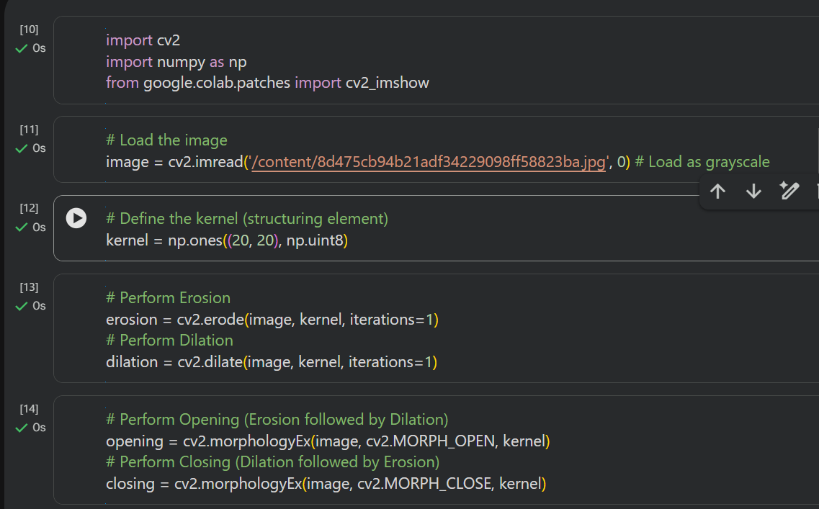
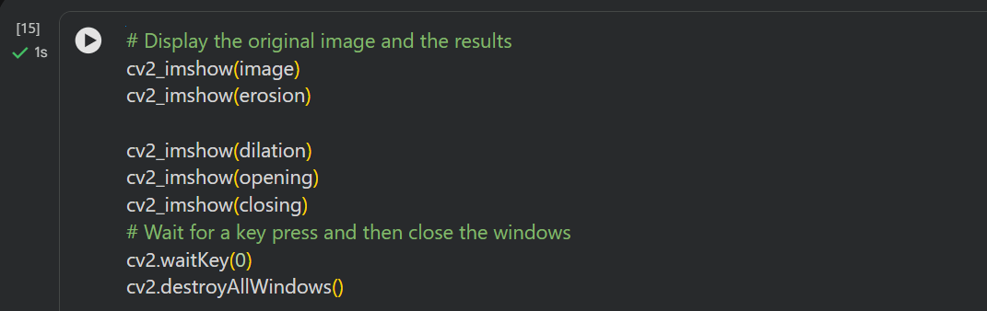

Output:
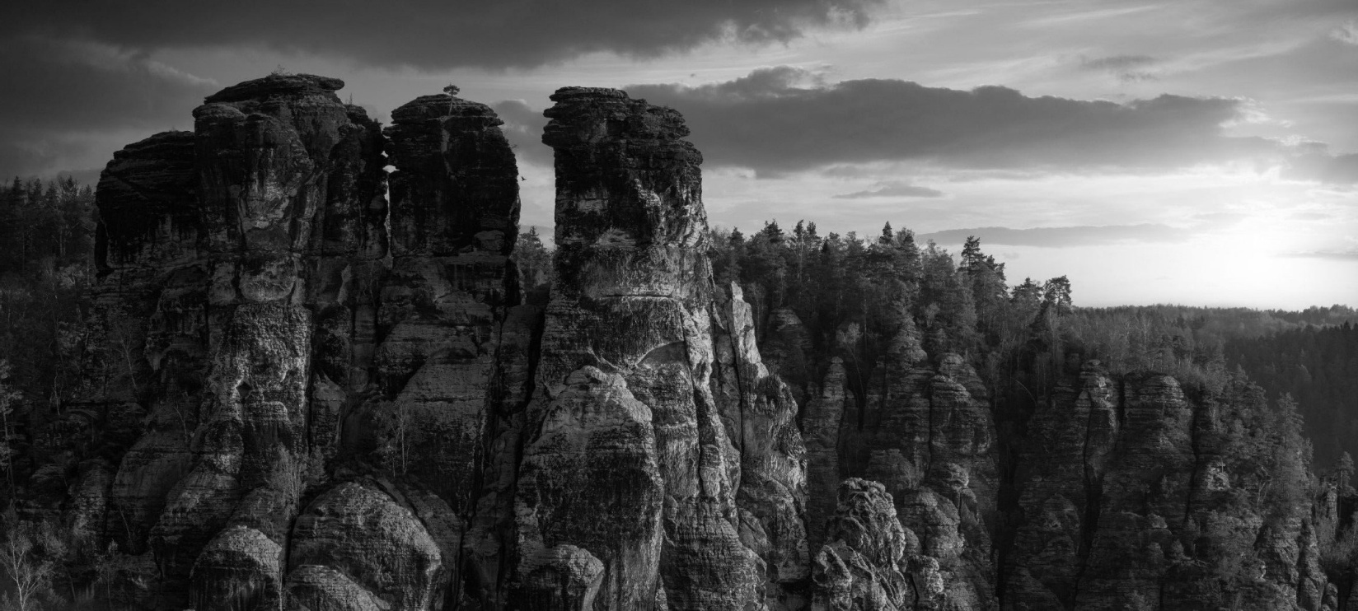
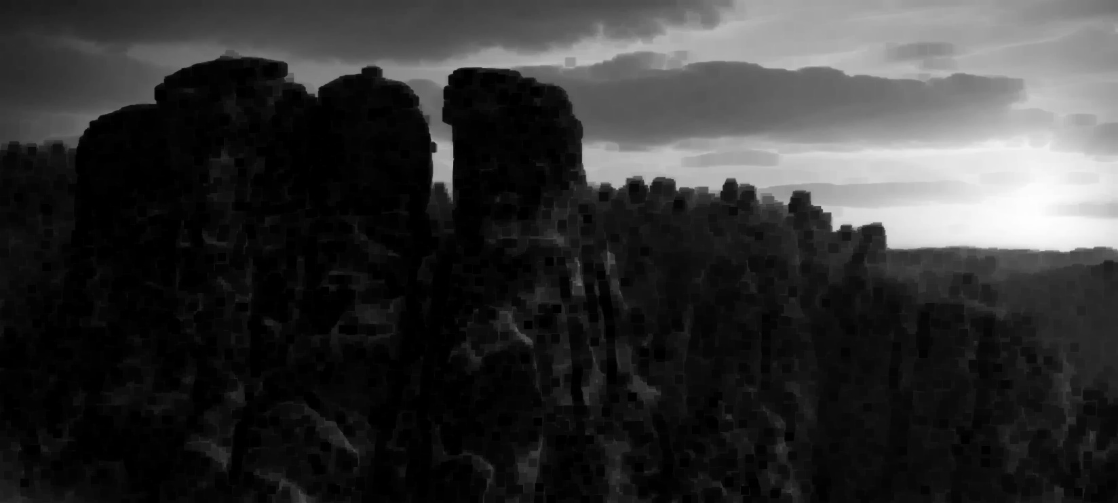
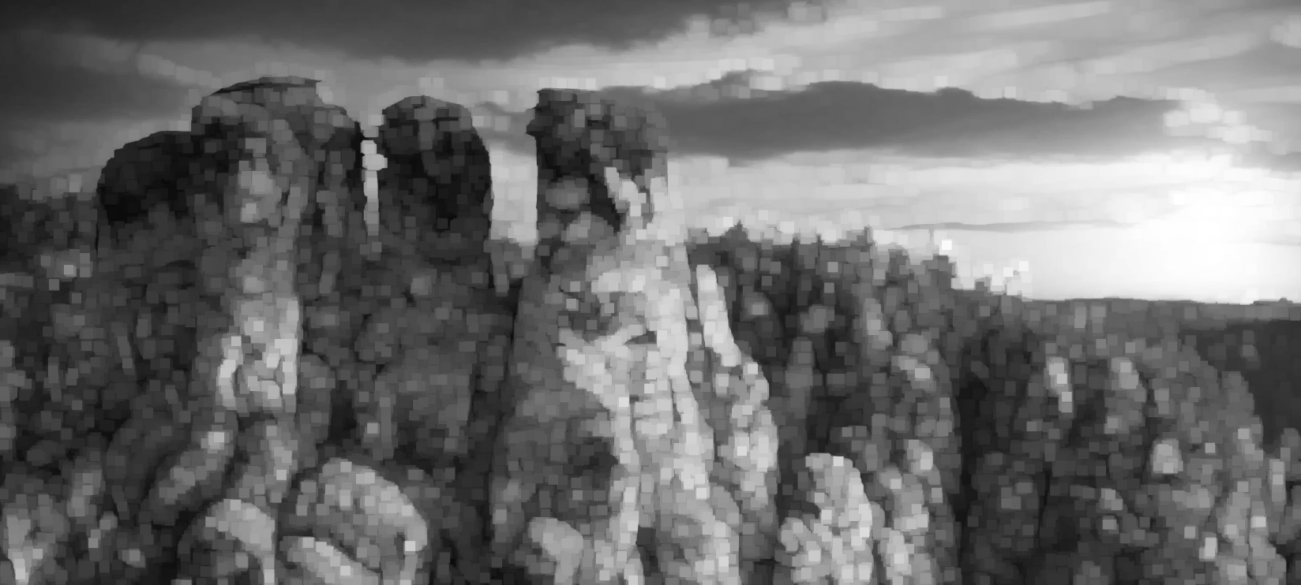
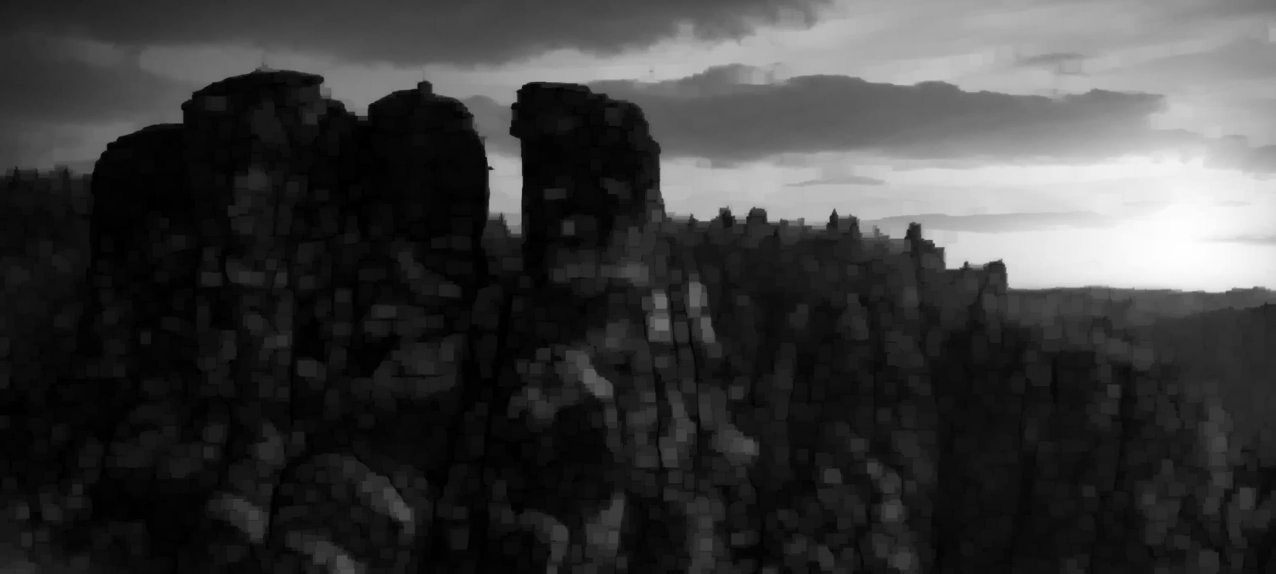
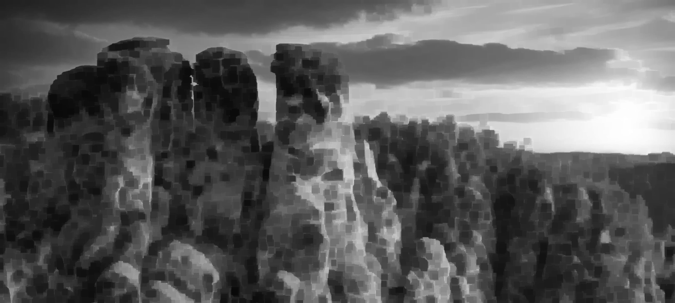

Conclusion:
In this experiment, dilation, erosion, opening, and closing operations were successfully performed on images using morphological techniques. I understood how dilation expands objects, while erosion shrinks their boundaries. Opening helped remove small noise and unwanted objects, whereas closing filled small gaps and holes. Overall, this experiment helped me understand how morphological operations are useful for modifying image structures and improving image quality.

Github Link:
https://github.com/divaparekh06/Digital-Signal-And-Image-Processing.git

